REACHING NEW HEIGHTS: AthletiCo Employees Climb Mt. Rainier

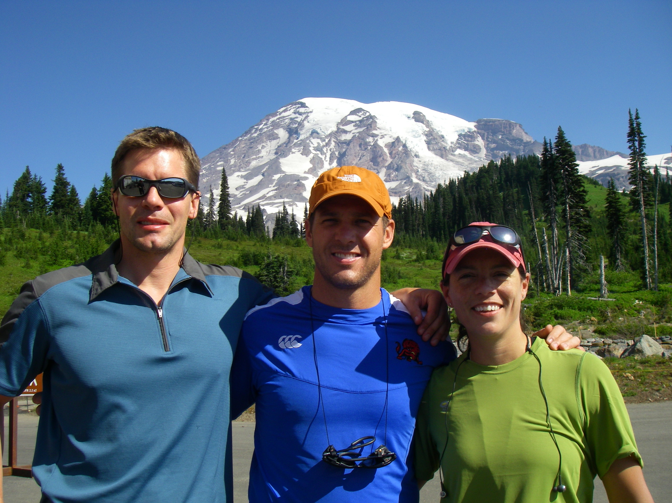)

On Sunday, July 19, AthletiCo’s Daphne Scott, PT, DPT, Paul Hadden, PT, ATC, and Craig Walters, PT, ATC, embarked on a unique adventure to climb the 14,410-foot volcano known as Mt. Rainier. The climbing expedition was part of a fundraising effort for the LiveActive Fund to raise awareness for orthopedic research.

The LiveActive Fund was created by John Golden and Dr. Brian Cole to generate the much needed funding to advance orthopedic research, education, and awareness for alternative treatments, therapies, and training to allow people to resume an active lifestyle. Scott, Hadden, and Walters were part of the LiveActive team, which was made up of 11 climbers and 4 guides. To prepare for the climb, they spent three months training their bodies for the rigors of both the conditions and the climb. This training included lower body strengthening and endurance training.

The team’s base camp was stationed just outside Mt. Rainier National Forest in Ashford, Washington. After finalizing their gear and food supply, the climb began on Monday with the team hiking up to 5,000 feet on a snowfield practicing how to handle potential issues that may arise on the climb. Hadden said they learned such things as how to maneuver in teams tied together with ropes and harnesses, as well as how to climb with crampons, metal spikes attached to their boots, which are important for walking in ice and snow.

On Tuesday, the team climbed to 10,000 feet reaching Camp Muir. Camp Muir served as a resting area where they ate freeze-dried meals and attempted to rest in tents and a bunkhouse. After only a couple hours of sleep, they left camp at 1:00 a.m. Wednesday morning to begin the last leg of the climb.

“For the last leg, Craig, Daphne, and I were roped together with a guide,” recalls Hadden. “We used headlamps to see, which made it interesting when negotiating rocks and trails, but overall it was a pretty easy accommodation. I remember looking up and only seeing headlamps above me and realizing how steep the terrain ahead of us really was. The hardest part of the ascent was negotiating the rocks with crampons on and finding the stamina needed to continue climbing.”

Cold temperatures of 25 degrees with 25-mph winds coupled with the steep terrain made the last few hours grueling. But the effort paid off when the team reached the summit around 8:00 a.m. After resting for 45 minutes, the team began the descent and were able to gain a different perspective of the terrain they successfully climbed.

Says Hadden, “It was interesting to see what we had climbed and the size of the slope and crevasses. Some of the cracks in the glaciers were 20 feet wide, and you couldn’t see the bottom. The expedition was such a great experience, and we were very proud to represent AthletiCo.”

